**Experiment 11**

**AIM:**

Write a program to create three objects for a class named pntr_obj with data members such as roll_no and name. Create a member function set_data() for setting the data values and print() member function to print which object has invoked it using ‘this’ pointer.

**Theory:**

Every object in C++ has access to its own address through an important pointer called this pointer. The this pointer is an implicit parameter to all member functions. Therefore, inside a member function, this may be used to refer to the invoking object. Friend functions do not have a this pointer, because friends are not members of a class. Only member functions have a this pointer.

**Code:**

1. #include < iostream >
2. using namespace std;
3. class pntr_obj {
4. char name[20];
5. int roll_no;
6. public:
7. void set_data() {
8. cin >> name >> roll_no;
9. }
10. void print() {
11. cout << "Name: " << this - > name << endl;
12. cout << "Roll#: " << this - > roll_no << endl;
13. }
14. };
15. int main() {
16. pntr_obj a, b, c;
17. a.set_data();
18. b.set_data();
19. c.set_data();
20. a.print();
21. b.print();
22. c.print();
23. return 0;
24. }

**Output:**

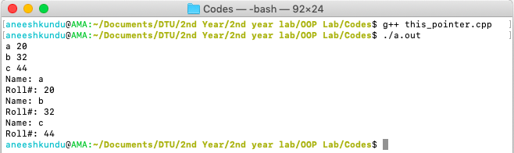

**Discussion:**

As it can be seen that we have printed the information of an object using ‘this’ pointer.